COPYWRITING CHEMISTRY SUCCESS PAGE.

Main product:

Copywriting Chemistry - The Legal Persuasion Hack for Telling People What They’re Dying to Hear, So They Give You Their Monies Willingly and Happily.

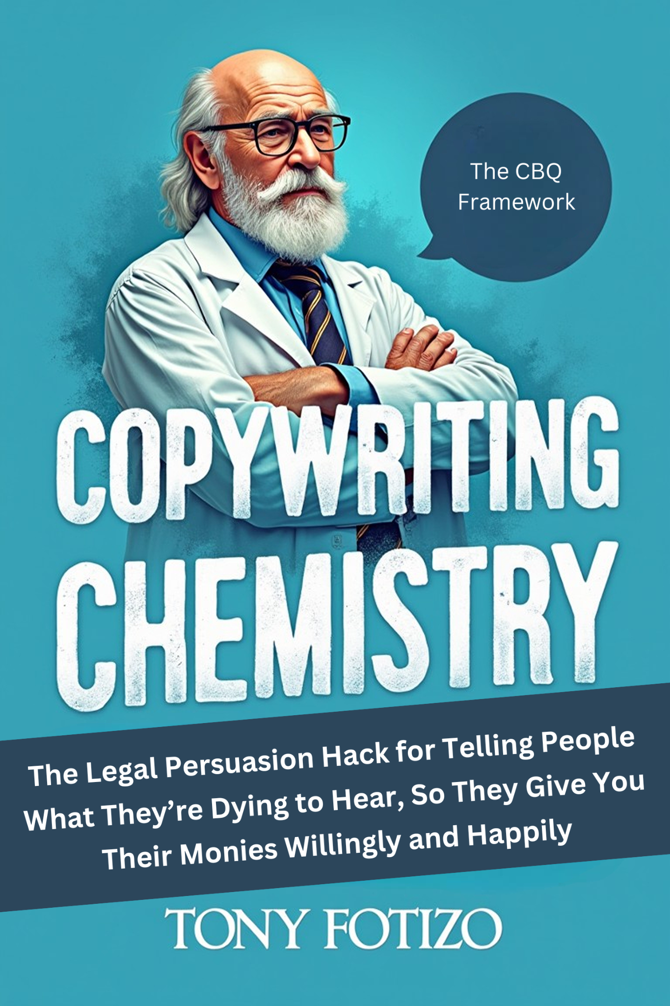

Click and request access:

https://docs.google.com/document/d/1nFFpViTFjuRumXJLH-KIRo6qap9m5fsOKHcm8g_7CGQ/edit?tab=t.0

Get the Bonuses Here:

1. How to Sell and Thrive in a Crowded, Highly Competitive Market As a Small Fish - “The Audience Resonance Index Protocol”.

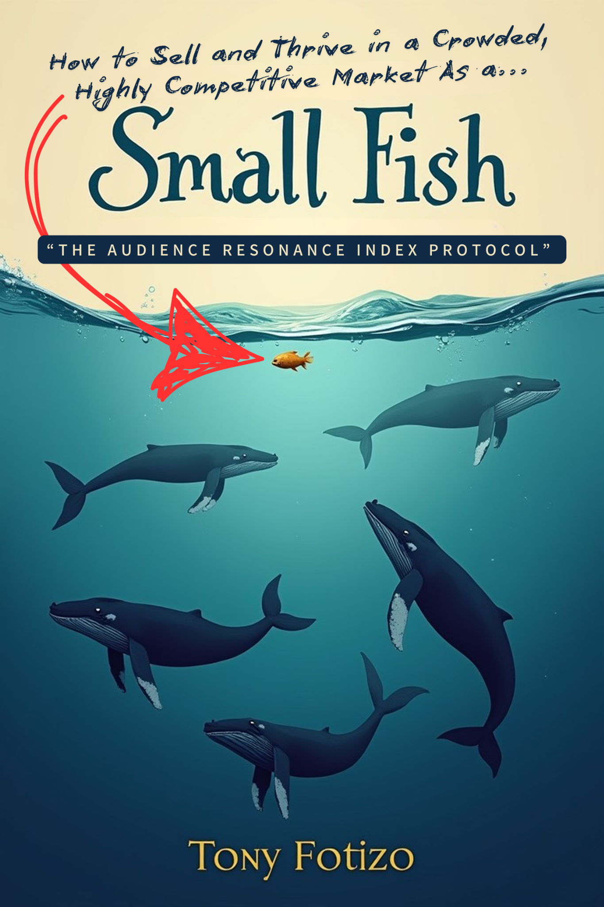

Click and request access:

https://docs.google.com/document/d/1GJlfy08y-kzIlZJvxp76WkitOJDA5KE2PVt0XmMQuVU/edit?tab=t.0

2. The Connection Cascade Method - The MAGIC of Building a Network of Bad-Ass Allies Who’ll Have Your Back and Help You Get Super RICH, Fast, as a Digital Marketer. GUARANTEED!

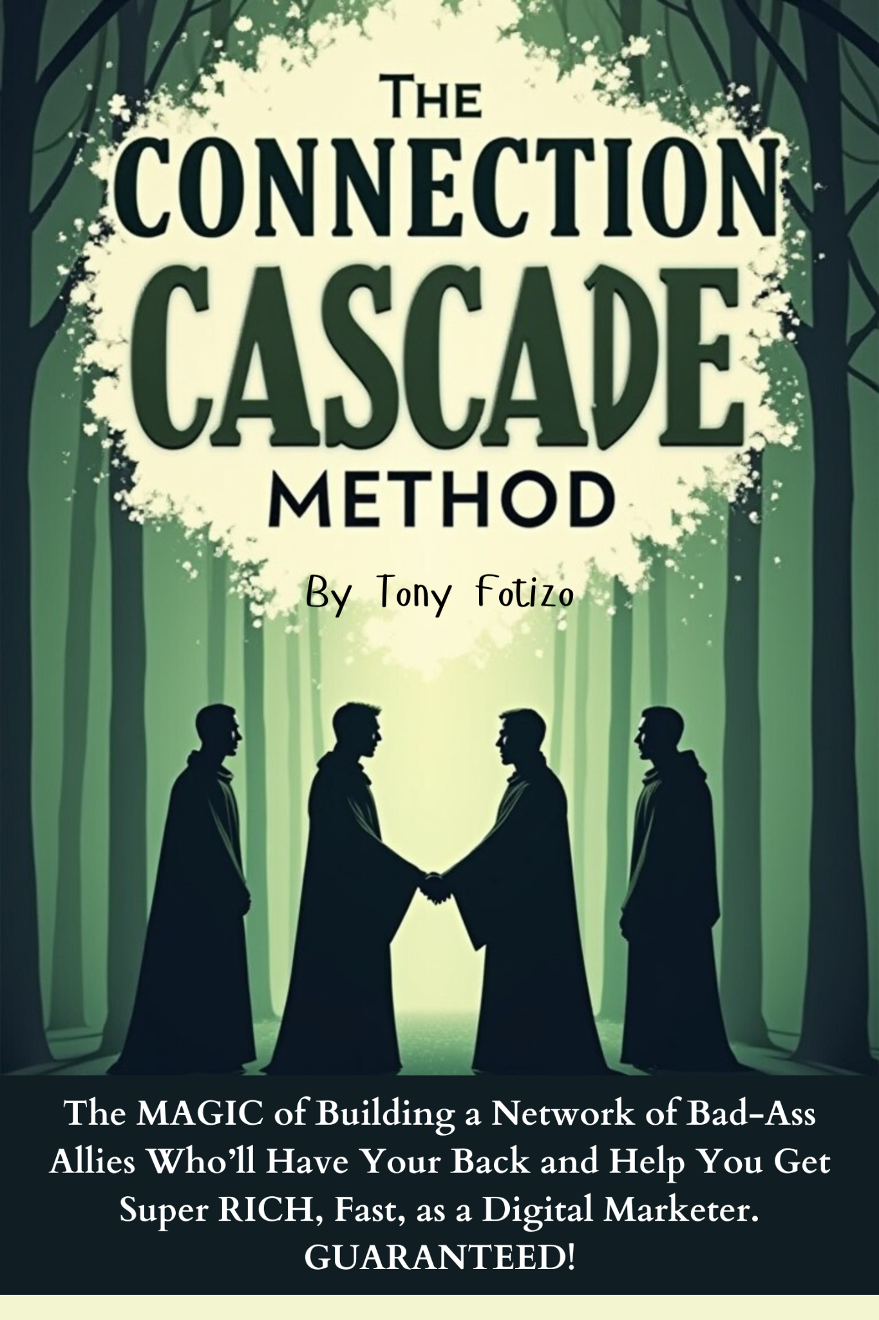

Click and request access:

https://docs.google.com/document/d/1oKCll-nygfqiqSg86beeKBwa2nCuiGXTczgKrPM2ApY/edit?tab=t.0

Kind Regards

Tony Fotizo’

Ps: If you have any questions email : mrfotizo@gmail.com

